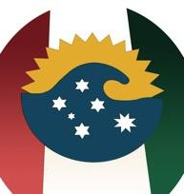
MENU

$32 Pepata di Cozze (Mussels) & Garlic Pizza
$29 Spaghetti Marinara
$29 Spaghetti with Chorizo, Capsicum & Napoli Chilli oil
$24 Grilled Dory with Lemon & Butter

$27 Grilled Barramundi with Lemon & Butter
$35 Rib Fillet with 3 sauces available (Mushrooms, Pepper & Diane)
$28 Chicken Parmi with Salad $ Chips
$22 Chicken Schnitzel with Vegetables & Mashed Potatoes
$15 Garlic Pizza
$16 Margherita Pizza
$20 Chorizo & Pepperoni Pizza
$18 Supreme Pizza
$18 Spinach & Feta Cheese Pizza
$10 Chips
$12 Wedges

